
QUALITY ALERT

Customer: AVANTI Date: Jun 18, 2024
Die: 15901 Colour: ALL
Type of Complaint: Curved/wavy fin

Q.A # Q.I.R # CUSTOMER NCR #

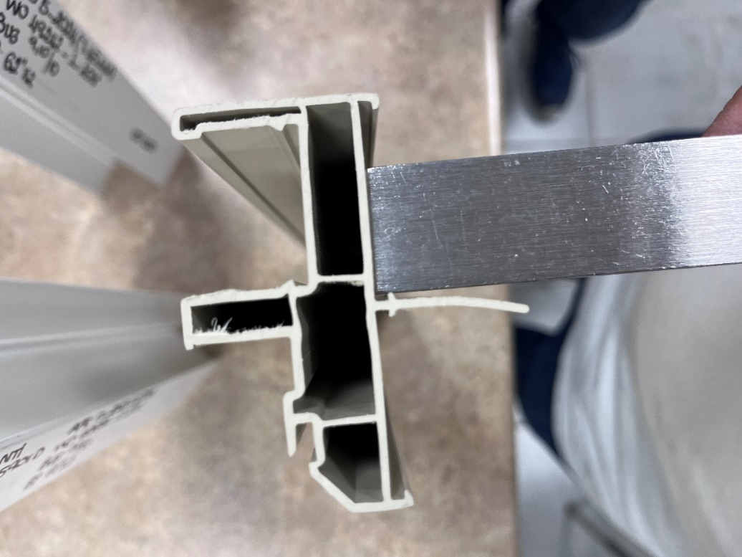
Description: Customer COMPLAINED material due to nail fin is curved/wavy.
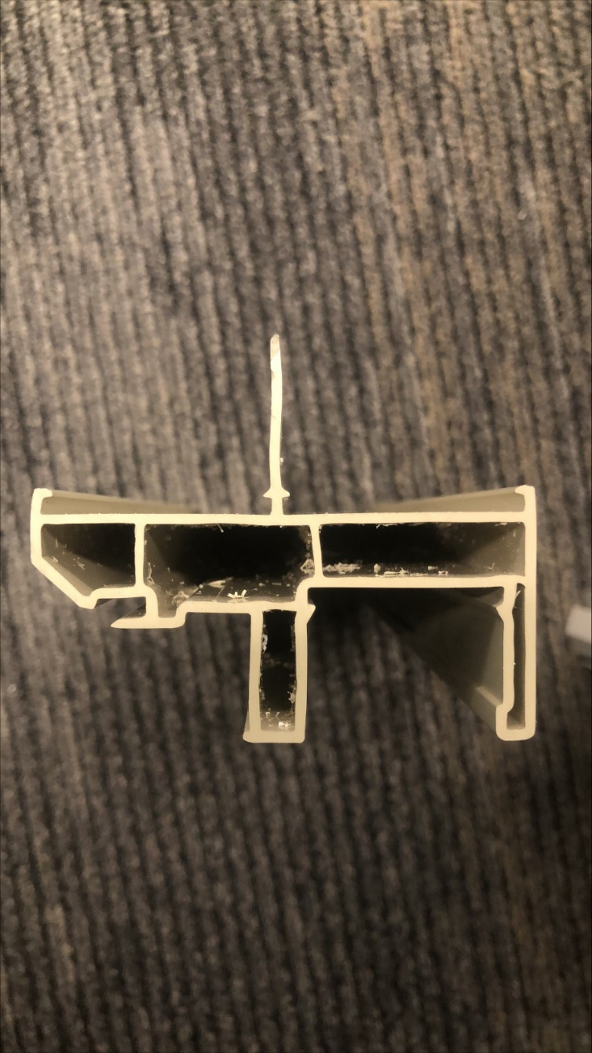

MAKE SURE NAIL FIN IS NOT WAVING, AND STRAIGHT AS MUCH AS POSSIBLE

BY SIGNING BELOW, YOU ACKNOWLEDGE THE PROBLEM ABOVE AND AGREE TO MONITOR THIS ISSUE IN FUTURE PRODUCTION RUNS.
DAY SHIFT |  | AFTERNOON SHIFT |  | NIGHT SHIFT
NAME | SIGNATURE | NAME | SIGNATURE | NAME | SIGNATURE

